Coding questions to help prepare for interviews.

* Write a program to swap two values of two variables without using third variable.
* Write a program to swap two values of two variables using pointers.
* Write a program to add two complex numbers.
* Write a program to read three sides of triangle. Check whether these sides make triangle. If they make then identify whether it is equilateral or isosceles or scalene.
* Write a program to print whether a given number is prime or not.
* Write a program to print all prime numbers within the given range.
* Write a program to print whether a given number is Armstrong number or not.
* Write a program to print the following patterns o
* * * * *
  + - * *

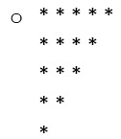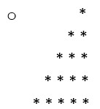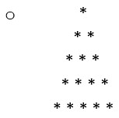

* + - * *
      * *

* * * *

o *

* + - * *

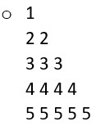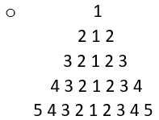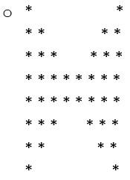

* + - * * *
      * * * *
      * * * * *
      * * * *
      * * *
      * *

*

* Write a program to reverse the given string and number.
* Write a program to count the number of digits in the number.
* Write a program to reverse the array.
* Write a program to find the maximum and minimum elements in the array.
* Write a program to count the number of vowels and consonants in the string.
* Write a program to find second largest and second minimum elements in the array.
* Given an array, rotate the array to the right by k steps, where k is non-negative.

o Input: nums = [1,2,3,4,5,6,7], k = 3 o Output: [5,6,7,1,2,3,4]

* Find the missing number, given an array of size N-1 with integers in the range of [1, N].
  + - Input: arr[] = {1, 2, 4, 6, 3, 7, 8}, N = 8
    - Output: 5
* Given an array and a value, remove all the occurrences of the given value in the array.
* Find the majority element in the array. A majority element in an array A[] of size n is an element that appears more than n/2 times.

o Input : {3, 3, 4, 2, 4, 4, 2, 4, 4} o Output : 4

* Given an array of integers nums and an integer **target**, return indices of the two numbers such that they add up to **target**. o Input: nums = [2,7,11,15], target = 9 o Output: [0,1]
* Given two integer arrays, return an array of their intersection. Each element in the result must appear as many times as it shows in both arrays.

o Input: nums1 = [4,9,5], nums2 = [9,4,9,8,4] o Output: [4,9] or [9,4]

* Write a program to check if the array contains a duplicate i.e., any value appears at least twice in the array.
* Write a program to check if given two strings are valid anagram
* Write a function to find the longest common prefix string amongst an array of strings.

o Input: strs = ["flower","flow","flight"] o Output: "fl"

* You are climbing a staircase. It takes n steps to reach the top. Each time you can either climb 1 or 2 steps. Write a program to return in how many distinct ways can you climb to the top?
* Given an integer array, find the contiguous subarray (containing at least one number) which has the largest sum and return its sum.

Note: A subarray is a contiguous part of an array.

o Input: nums = [-2,1,-3,4,-1,2,1,-5,4] o Output: 6 subarray: [4,-1,2,1]

* Given a string, find the length of the longest substring without repeating characters.

o Example: For “ABDEFGABEF”, the longest substring are “BDEFGA” and “DEFGAB”, with length 6.

* Write a program to sort an array using- bubble sort, insertion sort, selection sort, merge sort, quick sort.
* Write a program to search an element in the array using- linear search, binary search.
* Stock Buy/Sell to Maximize profit o The cost of a stock on each day is given in an array. Find the maximum profit that you can make by buying and selling on those days. If the given array of prices is sorted in decreasing order, then profit cannot be earned at all
  + Input: arr[] = {100, 180, 260, 310, 40, 535, 695} o Output: 865
  + Explanation: Buy the stock on day 0 and sell it on day 3 => 310 – 100 = 210

Buy the stock on day 4 and sell it on day 6 => 695 – 40 = 655 Maximum Profit = 210 + 655 = 865

* Write a program to find the count the frequencies of elements of a given integer array.
* Write a program to find number of occurrences of a word in a string.
* Write a program to convert a decimal number to its binary equivalent using function.
* Given a string, output count of each character and the character.

o Input: aaabbcd o Output: 3a2b1c1d

* Find minimum number of currency notes and values that sum to given amount o We may assume that we have infinite supply of notes of values {2000, 500,

200, 100, 50, 20, 10, 5, 1} o Input : 800

o Output : Currency Count

500 : 1

200 : 1

100 : 1

* Write a program to merge two sorted arrays without using extra space.
* Write a program to find the contiguous sub-array(containing at least one number) which has the maximum sum and return its sum. (Kadanes Algorithm) o Input: N = 5 arr[] = {1,2,3,-2,5} o Output: 9
* Write a program to find check whether a subarray exists with its sum equal to 0.
* Write a program to find the minimum number of operations required to make the string palindrome.
* Write a program to sort the first half of array in ascending and second half in descending order.
* Write a program to print sum of all rows of the 2D-matrix.
* Write a program to print the 2D-matrix in spiral form.

o Input: matrix = [[1,2,3],[4,5,6],[7,8,9]] o Output: [1,2,3,6,9,8,7,4,5]

* Given an unsorted array and a number n, find if there exists a pair of elements in the array whose difference is n.

o Input: arr[] = {5, 20, 3, 2, 50, 80}, n = 78 o Output: Pair Found: (2, 80)

* Given an integer array nums, return all the triplets [nums[i], nums[j], nums[k]] such that i != j, i != k, and j != k, and nums[i] + nums[j] + nums[k] == 0.

o Input: nums = [-1,0,1,2,-1,-4] o Output: [[-1,-1,2],[-1,0,1]]

* Write a program to invert the ith bit of the given number and print the number formed.
* Write a program to check whether the given number is power of 2 or not.
* Given an array of size n, Write a function that returns an equilibrium index (if any) or -1 if no equilibrium index exists. o Note: The equilibrium index of an array is an index such that the sum of elements at lower indexes is equal to the sum of elements at higher indexes.

o Input: A[] = {-7, 1, 5, 2, -4, 3, 0} o Output: 3

3 is an equilibrium index, because:

A[0] + A[1] + A[2] = A[4] + A[5] + A[6]

* Write a program to find distinct element in each row of the matrix.
* Given the list of N names, print it based on the alphabetical order of the first letter. If the first letter of the two names is the same, print it in the order in the array. o If the Names are Alice, Bob, Noah, Adam. Print it as Alice, Adam, Bob, Noah
* Write a program to remove duplicates from the string.
* Write a C program to remove 3 or more consecutive characters from a string, repeat until there are no more

o Ex: MNHHHHNNM => MNNNM => MM

* Implement Stack from scratch using array and linked list.
* Write a program to convert infix expression to postfix expression.
* Write a program to evaluate postfix expression.
* Write a program to reverse a string using stacks.
* Write a program to sort a stack.
* Implement queues from scratch using array and linked list.
* Write a program to reverse the contents of queue and stack
* Implement a browser that shows the current page it is in.

You have 3 commands o 1)”forward”: It goes to the forward page if there is any else it returns the link of the current page. If the browser is on the home page it prints “HOME”.

* + 2)”backward”: It goes to the back page and prints the link to that page. If the browser is on the home page then it prints “HOME”
  + 3)”goto”: It goes to the link mentioned and prints the link of the current page.

The first or default page in the browser is the “HOME” page.

* + Output: the current page the browser is in.
* Implement Singly and doubly linked list from scratch.
* Write a program to sort two sorted singly linked list.
* Write a program to detect loop in a linked list.

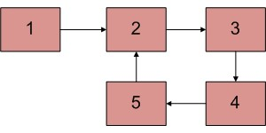o Linked list with a loop.

* Write a program to find intersection of two linked list.
* Write a program to reverse a linked list.
* Write a program to remove duplicates from a doubly linked list.
* Write a program to traverse a binary tree. (Implement all three traversals)
* Write a program to find the depth of the tree.
* Write a program to print the left, right, top, bottom view of the binary tree.
* Given a binary tree, find if it is height balanced or not.

A tree is height balanced if difference between heights of left and right subtrees is not more than one for all nodes of tree.

* Write a program to return the level of the given node in the binary tree.
* Write a program to find sum of leaf nodes of the binary tree.
* Write a program to implement BFS and DFS.
* Given a Graph, count number of triangles in it. The graph is can be directed or undirected.
  + Input: digraph[V][V] = { {0, 0, 1, 0},

{1, 0, 0, 1},

{0, 1, 0, 0},

{0, 0, 1, 0}

};

* + Output: 2
  + 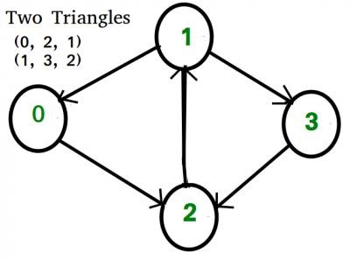
* Write a program to implement Dijkstra’s Algorithm.
* Given a set of N items, each with a weight and a value, represented by the array w[] and val[] respectively. Also, a knapsack with weight limit W.

The task is to fill the knapsack in such a way that we can get the maximum profit.

Return the maximum profit.

o Note: Each item can be taken any number of times.

Next step:

* Keep practicing and competing on [leetcode](https://leetcode.com/problemset/all/) and [codechef.](https://www.codechef.com/practice?end_rating=999&group=all&hints=0&itm_campaign=problems&itm_medium=home&limit=20&page=0&search=&sort_by=difficulty_rating&sort_order=asc&start_rating=0&tags=&topic=&video_editorial=0&wa_enabled=0)
* Learn solving problems using dynamic programming and greedy approach.

Additional DSA questions : [Click here:)](https://docs.google.com/spreadsheets/d/1DsKMVq3UwPNxF-H9BcOD109UcPI49dg6/edit?usp=sharing&ouid=102357827824529067644&rtpof=true&sd=true)

If you have any queries, feel free to -

[Connect on LinkedIn](https://www.linkedin.com/in/sumeet-bafna)  or

Send an email